Technical Specification

Note: all companies have to bring their samples with all technical specifications for positions 1,2,3 and 4.

No. | Description | Requirement | Supplier’s Offer
1 | Arc protection visor (face shield)  Face shield that can be adjusted to all kind of safety helmets without needing to modify its characteristics. It is composed of a nylon adapter and a reclining visor. It repels molten metals, impacts at its highest level, liquid splashes, and the electric arc risk. It filters I.R. solar radiation. According to EN 166 standard. UV protection 100%.  Must be compatible with the position safety helmet (refer photo 2). | 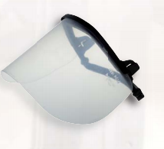  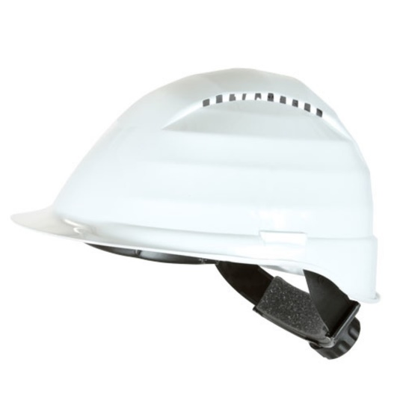
2 | Double pole low voltage detector  - LV detector must be digital type and suitable for field Works and easy to use.  - Device must have two poles for voltage detection. Also if needed device must be available to be used with single pole for voltage detection.  - Working frequency must be 40-400 Hz.  - Measurement interval must be 12 V – 690 V AC/DC.  - Voltage levels must be shown on the screen or must have voltage level indicators.  - The voltage detector must be compatible with the standard IEC and/or EN 61243-3.  - Must have positive/negative polarity  - Must have continuity test with sound and light indicators.  - Device must be working under temperatures of -15oC and +45oC flawlessly.  - Must have power saving mode. When not used it must close itself.  - All test and quality documents must be given with offer.  - Guarantee period must be at least two years.  - One sample should be sent for testing.  - Security level of the detector must be CAT IV 600 V  - Detector must hold the last measurement on indicator or screen  - Device must have IP64 protection class  - Test probes of the device must be connected with only one cable. It shouldn’t have two independent test cables. | 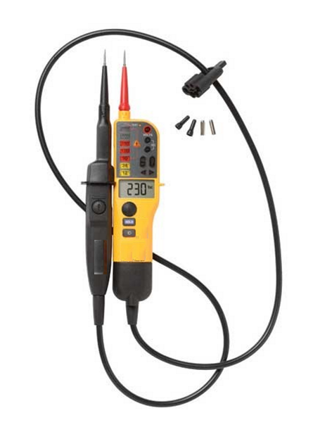
3 | 1000 V isolated screw driver set  - It must be made chrome vanadium, black oxide covered, PP insulated.  - It must consist of 6 pieces. (2,5x75mm – 4x100mm – 5,5x 125mm – 6,5x150mm flat pointed), (4x80mm – 6x100mm star pointed)  - Isolation must be from top to bottom excluding just active nose part.  - Isolation must be 1000 VAC and 1500 VDC and must be compatible with the standard of IEC 60900. IEC 60900 compatibility must be written on the isolation alongside double triangle symbol undeletable. | 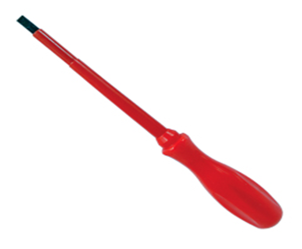
4 | Protective water resistant glove against mechanical hazards, wrists cutting protection  Characteristics  - Material: Seamless knit nylon/lycra glove with micro-foam nitrile coating.  - Artery protection. Five finger gloves, water resistant.  - Single-piece index finger.  - Use: minor and medium handling, wrist cutting protection, outside work in bad weather.  - These models of gloves are designed to offer protection against mechanical hazards. Used in applications which require a high degree of dexterity and sensitivity, especially where grip is important, such as handling small oily parts and components, general assembly, machining, micro-engineering etc.  - Performance level: abrasion 2, cutting 1, tearing 2 and puncture 1.  - Standard:  EN 420.  EN 388.  - Size: L | 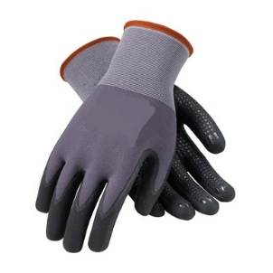  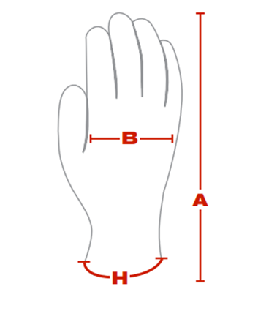
5 | Measuring device of vibration level  - The equipment must be must be fully compatible with ISO 2954 standard.  - Aplication: Measurement of vibration level of industrial machnies.  - Measuring functions: Velocity, Acceleration RMS value, Peak value, Max. & Min. value.  - Range: Velocity 200 mm/s, Acceleration 200 mm/s2.  - Frequency range: 10 Hz up to 1kHZ.  - Accuracy: ± (5 % + 2 digits ) reading.  - Interface: USB.  - The equipment must have the CE certification on it.  - The equipment should be appropriate for hand holding and positioning, with dimensions same as ordinary multimeters.  - This product must have a display to show the measuring result, command entering buttons and it must provide clear and easily approachable menu for selection of wanted measuring function.  - The equipment must have rechargeable batteries, adapter, warning system of battery capacity level and automatically turn off when this level reaches zero%.  - The equipment must have additional portable accessories, probes or adjustable length cable for application depending on selected function for measurement.  - The equipment must have written on the outer part the name and symbol of production company, nominal voltage and current without possibility of being deleted.  - The equipment must be delivered with all instructions for use and technical specifications that also include maintenance conditions, maximum lifetime, and attesting period if it’s necessary, in English and Albanian language, and a storage bag or box. | 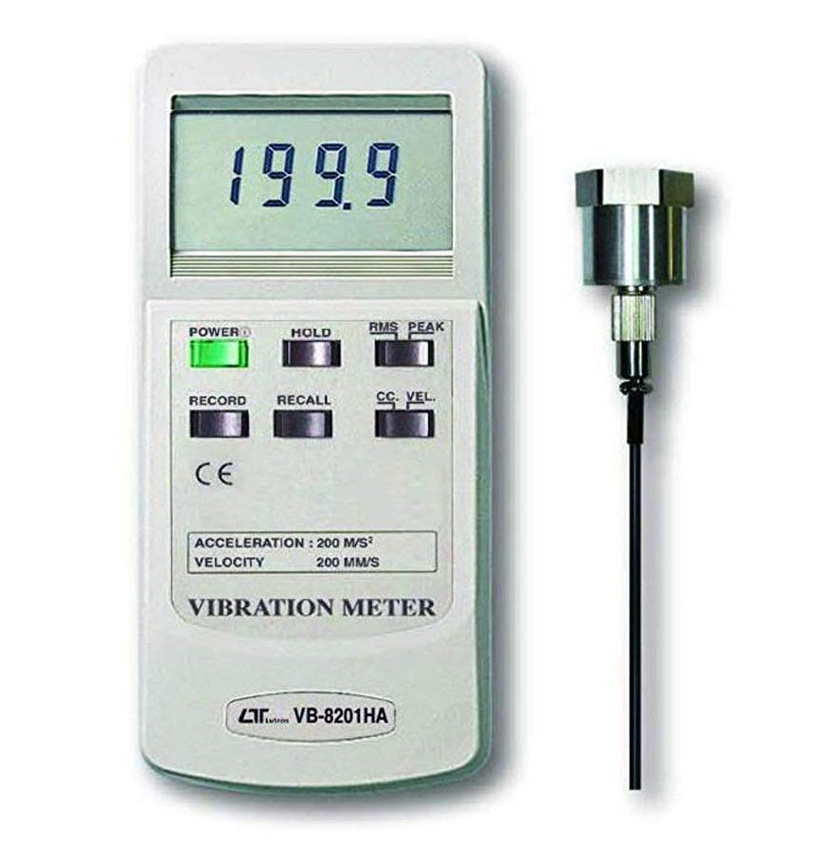
6 | Multi-tester for installation safety testing  It should be an equipment that can perform these tests and measurements:  - Voltage and frequency  - Continuity test  - Insulation resistance test  - Earthing resistance tests (including pe test terminal, e.g. From socket)  - Rcd testing (trip-out current, trip-out time, contact voltage, rcd auto test)  - Voltage drop for any part of electrical installation.  - Other.  - The equipment must have an accuracy class not more than ∓5% of reading and depending on type and measurement range, up to 10 digits.  - The equipment must be must be fully compatible with standard EN 61557 and as a reference it might have the standards EN 61010, EN 61009, EN 60364. These compatibility and test reports must be done and approved from independent and accredited laboratories for any standard.  - The equipment must be applicable for periodical testing of business and industrial object electrical installations, testing of single and multiphase systems, testing of TT and TN systems.  - The equipment must be applicable for measurements up to 230V ac voltage and frequency of 50HZ.  - The equipment must have the CE certification on it.  - The equipment should be appropriate for hand holding and positioning, with dimensions same as ordinary multimeters.  - This product must have a display to show the measuring result, command entering buttons and it must provide clear and easily approachable menu for selection of wanted testing function.  - The equipment must have rechargeable batteries, adapter, a warning system of battery capacity level and automatically turn off when this level reaches zero%.  - The equipment must have additional portable accessories and adjustable length cable for application depending on selected function for testing/measurement.  - The equipment must have written on the outer part the name and symbol of production company nominal voltage and current without possibility of being deleted.  - The equipment must be delivered with all instructions for use and technical specifications that also include maintenance conditions, maximum lifetime, and attesting period if it’s necessary, in English and Albanian language, and a storage bag or box. | 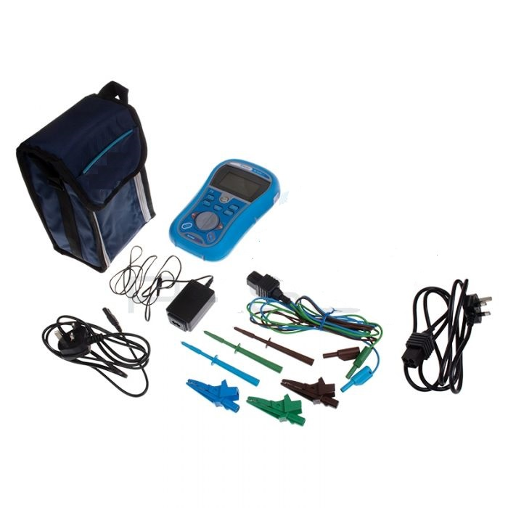
7 | Environmental conditions measuring device | 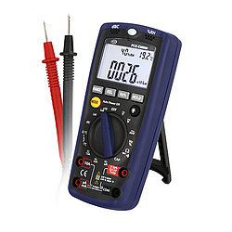
  Sound
  Measurement range: | 35 ... 100 dB
  Resolution: | 0.1 dB
  Frequency range: | 30 Hz ... 10 kHz
  Accuracy: | ± 5 dB at 94 dB, 1 kHz sine wave
  Microphone: | Internal, electric condenser
  Light
  Measurement range: | 4,000 ... 40,000 lux (40,000 lux range reading x 10)
  Accuracy: | ± 5% measurement value + 10 digits  (calibrated to standard incandescent lamp at color temperature 2856k)
  Repeatability: | ± 2%
  Sensor: | Internal
  Humidity
  Measurement range: | 33 ... 99% relative humidity (RH)
  Resolution: | 1% RH
  Accuracy: | ± 3% measurement value + 5% RH
  Temperature
  Measurement range: | Indoor: 0 ... 50°C  Type K: -20 ... 1300°C
  Accuracy: | ± 3% measurement value ± 3°C
  Electrical
  AC / DC current (auto-ranging for uA and mA)  Measurement range  Resolution  Accuracy | - 400-uA / 4000-uA / 40-mA / 400-mA / 10 A  - 0.1-uA / 1-uA / 10-uA / 100-uA / 10-mA  - ± 1% measurement value ± 2 digits (up to 40-mA DC)  - ± 1.2% value ± 2 digits (up to 400-mA DC / 40-mA AC)  - ± 1.5% value ± 2 digits (up to 400-mA AC)  - ± 2% value ± 5 digits (up to 10 A)
  Resistance (auto-ranging)  Measurement range  Resolution  Accuracy | - 400 Ω / 4 kΩ / 40 kΩ / 400 kΩ / 4 MΩ / 40 MΩ  - 0.1 Ω / 1 Ω / 10 Ω / 100 Ω / 10 kΩ / 1 MΩ  - ± 1.5% value ± 4 digits (up to 400 Ω)  - ± 1.5% value ± 2 digits (up to 400 kΩ)  - ± 2% value ± 2 digits (up to 4 MΩ)  - ± 2.5% value ± 2 digits (up to 40 MΩ)
  Capacitance (auto-ranging)  Measurement range  Resolution  Accuracy | - 50 nF / 500 nF / 5 uF / 50 uF / 100 uF  - 10 pF / 0.1 nF / 1 nF / 10 nF / 0.1 uF  - ± 5% value ± 20 digits (up to 50 nF)  - ± 3% value ± 5 digits (up to 50 uF)  - ± 4% value ± 5 digits (up to 100 uF)
  Frequency (auto-ranging)  Measurement range  Resolution  Accuracy | - 5 Hz / 50 Hz / 500 Hz / 5 kHz / 50 kHz / 500 kHz / 10 MHz  - 0.001 Hz / 0.01 Hz / 0.1 Hz / 1 Hz / 10 Hz / 100 Hz / 1 kHz  - ± 1.2% value ± 3 digits (up to 500 kHz)  - ± 1.5% value ± 4 digits (up to 10 MHz)
  General specifications
  - The equipment must be must be fully compatible with EN 61010 safety standard and CAT III 600.
  - Measuring functions: Sound level, relative humidity, light intensity, temperature.
  - The equipment must have the CE certification on it.
  - The equipment should be appropriate for hand holding and positioning, with dimensions same as ordinary multimeters.
  - This product must have a display to show the measuring result, command entering buttons and it must provide clear and easily approachable menu for selection of wanted measuring function.
  - The equipment must have written on the outer part the name and symbol of production company, nominal voltage and current without possibility of being deleted.
  - The equipment must be delivered with all instructions for use and technical specifications that also include maintenance conditions, maximum lifetime, and attesting period if it’s necessary, in English and Albanian language, and a storage bag or box.
  Accessories: | Test leads, Temperature probe, carrying case,
  Display: | LCD
  Operating conditions: | 0 ... 40°C < 70% RH
  Storage conditions: | -10 ... 60°C < 80% RH
  Power supply: | The equipment must have rechargeable batteries, adapter, warning system of battery capacity level and automatically turn off when this level reaches zero%.
8 | Light intensity measuring device  - The equipment must be must be fully compatible with EN 61010-1 standard CAT III 600, EN 50081-1 and EN 50082-1 standards  - Aplication: Measurement of light intensity.  - Range: 0 up to 200000 lux or 0 up to 400000 lux.  - Resolution: 0.01 / 0.1 / 1 / 10 / 100 Lux.  - Accuracy: ±4% (<10k Lux); 5% Scale (> 10 k Lux) or ± 5% of reading ± 10 digits (<10,000 lux) and ± 10% of reading ± 10 digits (>10,000 lux).  - Repeatability: ± 3%.  - The equipment must have the CE certification on it.  - The equipment should be appropriate for hand holding and positioning, with dimensions same as ordinary multimeters.  - This product must have a display to show the measuring result, command entering buttons and it must provide clear and easily approachable menu for selection of wanted measuring function.  - The equipment must have rechargeable batteries, adapter, warning system of battery capacity level and automatically turn off when this level reaches zero%.  - The equipment must have written on the outer part the name and symbol of production company, nominal voltage and current without possibility of being deleted.  - The equipment must be delivered with all instructions for use and technical specifications that also include maintenance conditions, maximum lifetime, and attesting period if it’s necessary, in English and Albanian language, and a storage bag or box. | 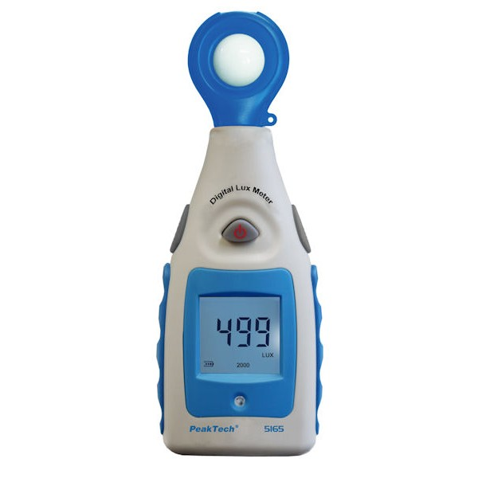  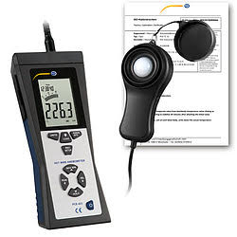
9 | Measuring device of wind (Anemometer)  - The equipment must be must be fully compatible with EN 61010-1 standard and CAT III 600.  - Aplication: Measuring the level of wind (air flow).  - Wind speed range: 0 up to 30 m/s.  - Resolution: 1.  - Accuracy: ± (3% + 0.3 m/s).  - Interface: USB.  - Temperature range: -20 ... 70°C / -4 ... 158°F.  - Resolution: 0.1°.  - Accuracy: ± 1.5°C / 34.7°F.  - The equipment must have the CE certification on it.  - The equipment should be appropriate for hand holding and positioning, with dimensions same as ordinary multimeters.  - This product must have a display to show the measuring result, command entering buttons and it must provide clear and easily approachable menu for selection of wanted measuring function.  - The equipment must have rechargeable batteries, adapter, warning system of battery capacity level and automatically turn off when this level reaches zero%.  - The equipment must have written on the outer part the name and symbol of production company, nominal voltage and current without possibility of being deleted.  - The equipment must be delivered with all instructions for use and technical specifications that also include maintenance conditions, maximum lifetime, and attesting period if it’s necessary, in English and Albanian language, and a storage bag or box. | 